System Topologies/Interconnection Structures: (How multiple processors are connected with memory and i/o devices?)
- Pattern of connections between the processors in a multiprocessor system.
- Diameter- maximum distance between 2 processors in the system.
- Bandwidth- capacity of communication link(L) multiplied by the number of such links in the system.
A. Shared Bus
B. Ring Topology
C. Tree Topology
D. Mesh Topology
E. Hypercube Topology
F. Completely connected Topology
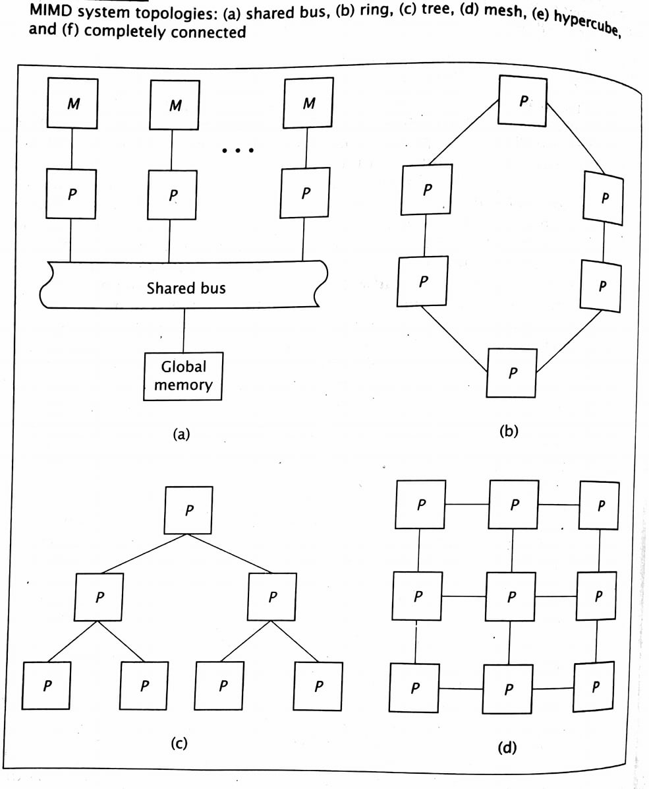
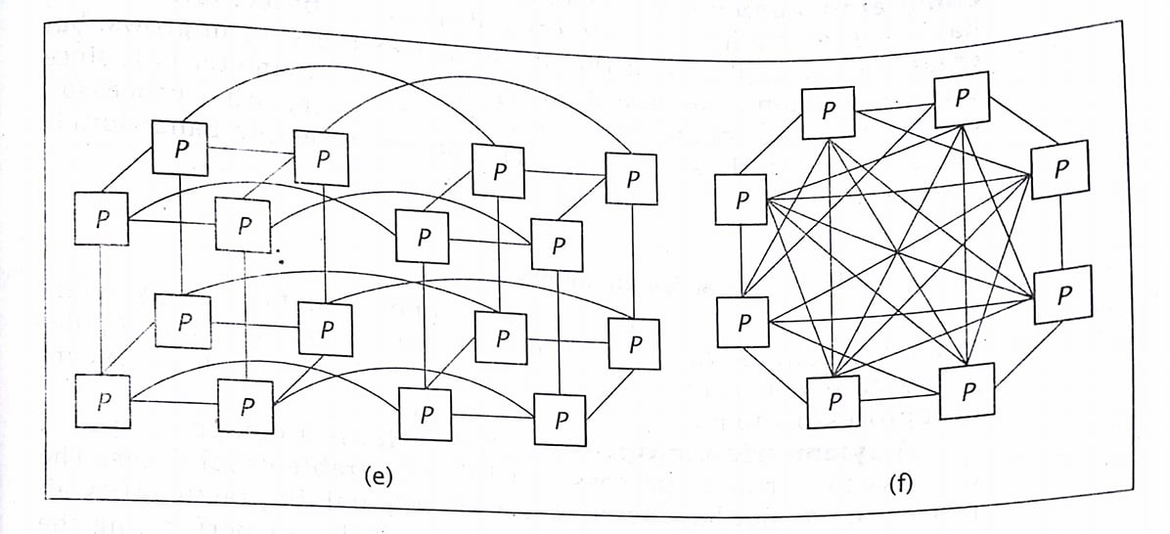
- A. Shared Bus
=> Processor communicates each other via bus.
=> Bus can handle only one data at time.
=> Processors directly communicate with their own local memory to limit traffic on bus.
=> Easy to expand.
=> Diameter = 1 and Bandwidth = 1. L
- B. Ring Topology
=> Uses direct dedicated connections between processors unlike shared bus.
=> All communication line to be active simultaneously.
=> Data travels through several processors to reach final destination.
=> Diameter = n/2(largest integer less than or equal to n/2)
=> Bandwidth = n . L
- C. Tree Topology
=> Direct connections between processors; each processor has three connections.
=> Primary advantage is its low diameter.
=> Diameter = 2(lg n); where lg n is the base 2 logarithm of the number of processors.
=> Bandwidth = (n - 1).L
- D. Mesh Topology
=> Every processor connects to the processors above and below it, and to its right and left.
=> Without wraparound connection (we can wrap and overlap from left to right and top to bottom, eg as in the figure)
- Diameter = 2√n and Bandwidth = (2n - 2√n) . L
=> With wraparound condition
- Diameter = √n and Bandwidth = 2√n . L
- E. Hypercube
=> Is a multidimensional mesh.
=> It has n processors, each with (lg n) connections.
=> Diameter = (lg n) and Bandwidth = (n/2) . (lg n) . L
- F. Completely Connected Topology
=> Each processor has (n-1) connections.
=> Increases the complexity of processor.
=> Diameter = 1 and Bandwidth = (n/2) . (n - 1) . L

